Exploring the Battle of the Somme
A toolkit for students and teachers

PART 1
Planning the attack
Maps were a vital part of planning an attack on German positions during the Battle of the Somme. Around 100,000 men were involved in the opening assault on 1st July 1916 and maps helped military commanders control the assaulting units’ positions before the attack started.

The map on Slide 1 shows the positions of British units before they attacked on 1st July 1916. It also shows how the frontline moved forward over the summer and autumn of 1916 and the final frontline on 18th November 1916.

How were British forces organised for the Battle of the Somme?
The volunteers who joined the army set up by Lord Kitchener were organised into battalions of 1,000 men.

These small units were part of a military command structure which helped senior military leaders organize the forces they controlled. The British forces on the Battle of the Somme were made up of six levels of command and led by Commander-in-Chief Sir Douglas Haig.
Battalions (1,000 men)
Corps
Brigades
Army
Divisions
Army Commander in Chief Douglas Haig
The battalions of men who joined up were organised into Brigades, Brigades were organised into Divisions, Divisions were organised into Corps and Corps made up an Army. They were formed into a chain of command.

In 1916 on the Somme, there were two Armies involved in the initial attack on 1st July, the Third Army and Fourth Army. You can see them on the map on Slide 1. The Third Army was commanded by General Allenby and the Fourth Army was commanded by General Rawlinson.

Military commanders used maps to plan their attack and different symbols were used to identify each type of unit. Infantry units were represented by a rectangular box with Roman numeral numbers inside them and sometimes the commander’s name placed below the box. Military planners used different letters above rectangular box to show the size of the unit, for instance ‘XXX’ to represent an infantry division. This is detailed in the table below.

Type of unit | Commander’s rank | Unit composition | Map symbol
Infantry Battalion | Lieutenant Colonel | Battalions were made up of around 1,000 infantrymen. | 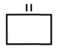
Infantry Brigade | Brigadier General | Four battalions made up a brigade | 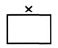
Infantry Division | Major General | 3 brigades made up a division | 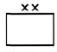
Corps | Lieutenant General | 2 divisions made up a corps | 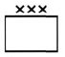
Army | General | 5 corps made up an army

EXERCISE 1
- How many days did the Somme Battle last?
- How many men are there in an infantry division?
- How many casualties did the 16th Division and 36th Ulster Division suffer during fighting on the 1st July and in September?
- Looking at the map on Slide 1, how many British Corps took part in the initial attack on 1st July 1916? What were their numbers?
- Why aren’t infantry battalions shown on the map?

PART 2

36TH (ULSTER) DIVISION AT THIEPVAL ON 1ST JULY 1916
Once the 36th Division was formed it commenced training to prepare its new recruits for war. A special training camp was established on Clandeboye estate near Bangor in County Down. Slide 3 shows a map of the training camp.

Slide 2 shows the type of training undertaken, which consisted of musketry (firing rifles), bayonet fighting, drilling, bomb throwing (using hand grenades) and marching.

An important skill they had to master was trench building. Notice how the trenches are zig-zagged and resemble a castle wall when observed from overhead. Diagram 1 shows the type of trenches they were instructed to build. Diagram 2 shows how they learned to build them in the following patterns. Diagram 3 they also were taught how to build barbed wire entanglements which were used by the Allies and Germans to defend their trenches.

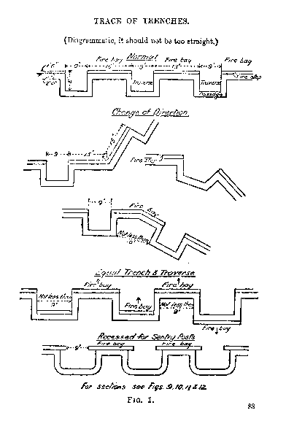
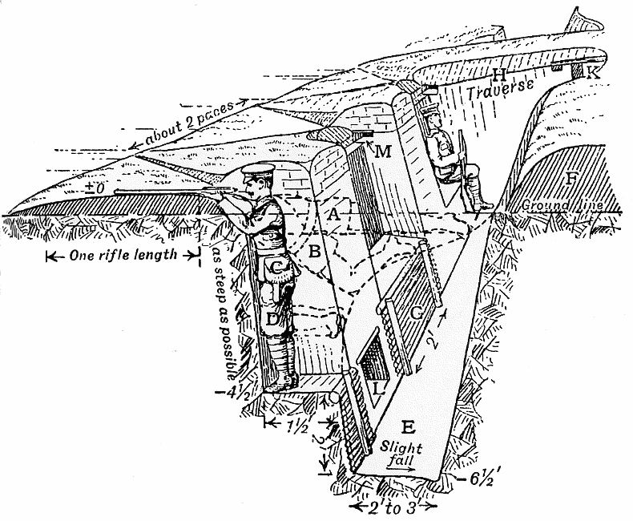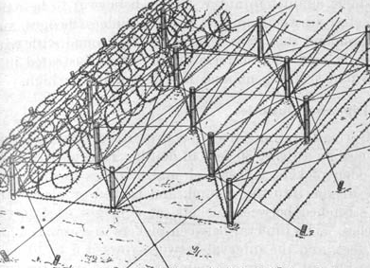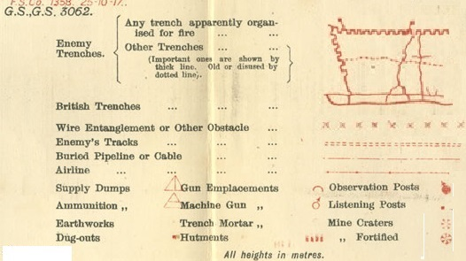
Diagram 4
Diagram 3
Diagram 2
Diagram 1

The 36th Division went to France in 1915. In early 1916 they were moved down to the Somme to prepare for the attack on the 1st July.

Slide 4 shows the actual maps that soldiers were given to use during the attack. These maps showed soldiers the terrain, features and obstacles they would have to overcome if they were to reach their objective at the Schwaben Redoubt, a German strong hold.

Military commanders used special symbols to mark features on the map, such as trenches. There was a key on the map so that the soldiers would know how to read the map. Diagram 4 shows the contours of the land, whether there were hills or the land was flat.

EXERCISE 2
- Why were trenches constructed in a zig zag way?
- Looking at the map on Slide 4 and using the key above, list the obstacles and features that soldiers faced in moving from their start positions to their objective at the Schwaben Redoubt?
- Are the British soldiers marching uphill or downhill to the Schwaben Redoubt during their attack? Give reasons for your answer.
- In kilometers, how far is it from the start point to the Schwaben Redoubt?

PART 3

16TH IRISH DIVISION ATTACK AT GINCHY, SEPTEMBER 1916

The 16th Division was moved to the Somme Valley ready for possible use during the Battle of the Somme in May 1916.

Between the 1st and 10th September, the 16th Division played an important part in capturing the towns of Guillemont and Ginchy. They captured Guillemont on 6th September and then Ginchy on the 10th. At the same time they were engaged in this attack, other units were launching attacks on Leuze Wood to their right and Delville Wood to their left of their position.
EXERCISE 3
- Looking at the map on Slide 5 and using the key above, list the obstacles and features that soldiers of the 16th Division faced in their line of advance?
- What measures could be taken to overcome such obstacles?
- What was different about the terrain and landscape that the men of the 16th Irish faced in their advance compared to that faced by the soldiers of the 36th Division?

